7.2: Institutional Best Practices
Best Practice:-1
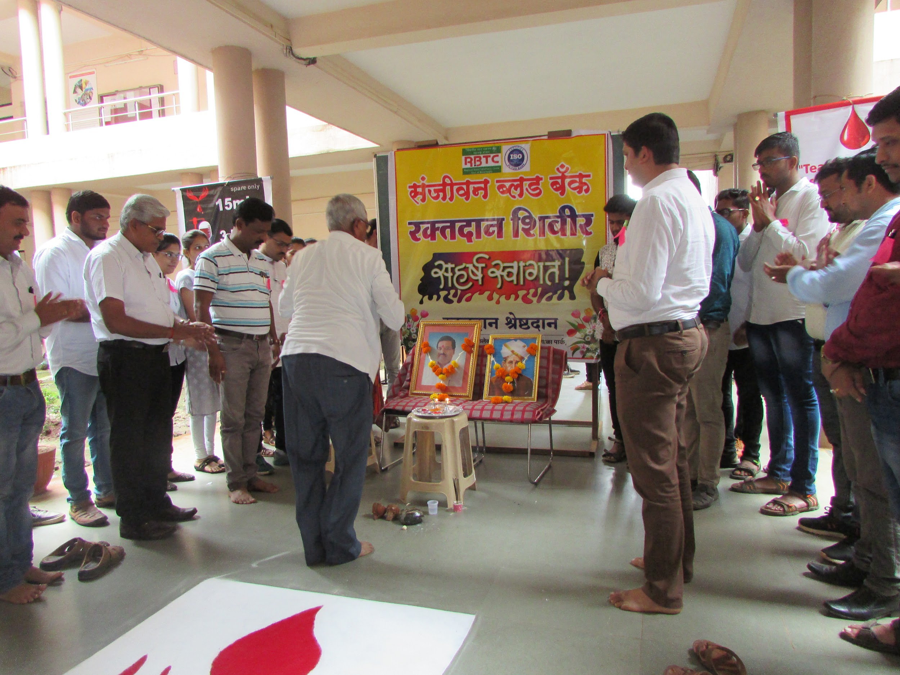 | 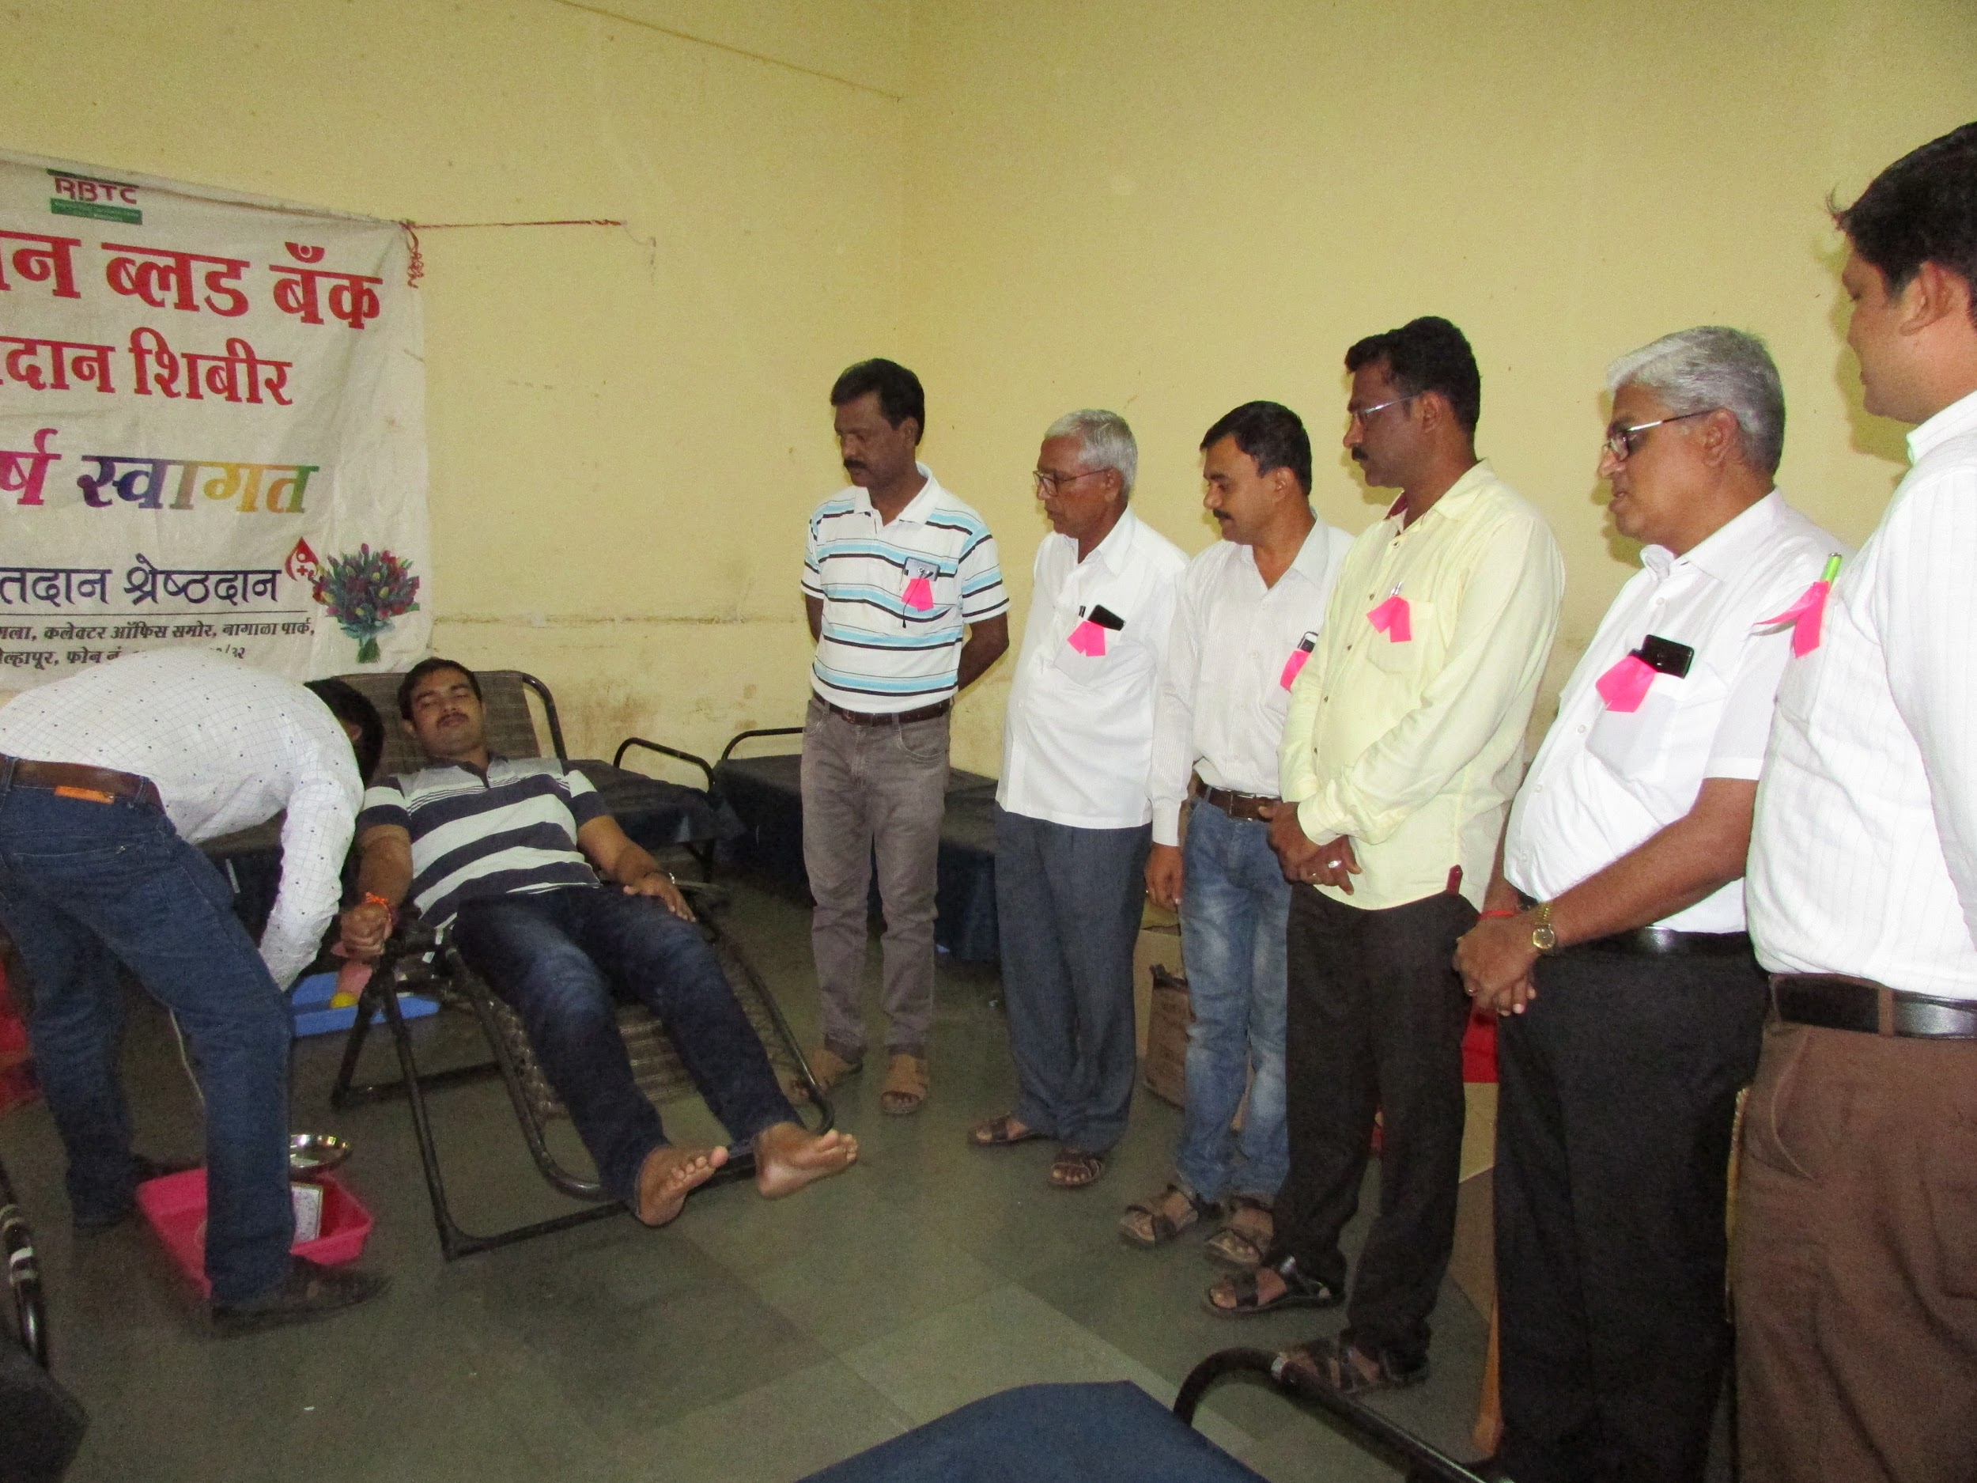
Caption: Inauguration of Camp | Caption: Blood Donation

Best Practice:-2
