2.7: Student Satisfaction Survey

Criterion II – Teaching–Learning and Evaluation
Student Satisfaction Survey on Teaching Learning Process
Following are questions for online student satisfaction survey regarding teaching -learning process.

Q.No. | Question
1 | How much of the syllabus was covered in the class?
  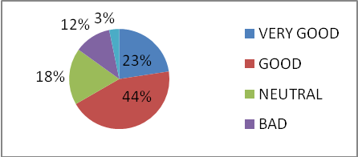
2 | How well did the teachers prepare for the classes? | 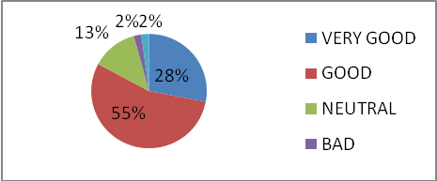
3 | How well were the teachers able to communicate? | 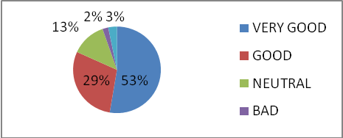
4 | The teacher’s approach to teaching can best be described as | 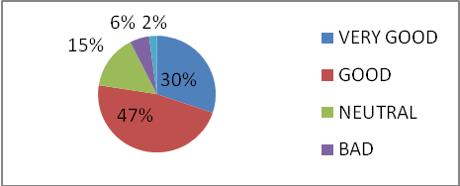
5 | Fairness of the internal evaluation process by the teachers. | 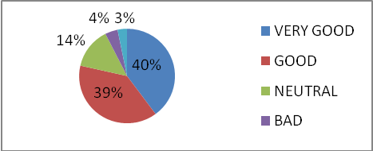
6 | Was your performance in assignments discussed with you? | 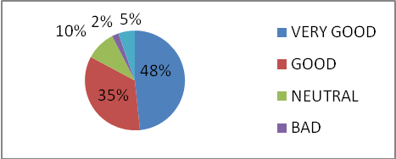
7 | The institute takes active interest in promoting internship, student exchange, field visit opportunities for students. | 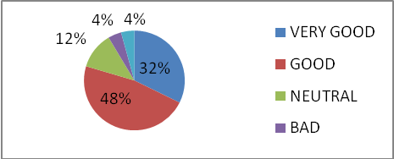
8 | The teaching and mentoring process in your institution facilitates you in cognitive, social and emotional growth. | 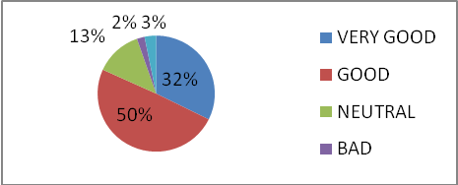
9 | The institution provides multiple opportunities to learn and grow. | 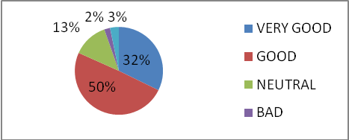
10 | Teachers inform you about your expected competencies, course outcomes and programme outcomes. | 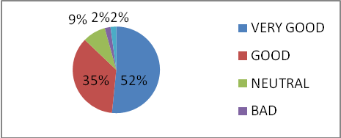
11 | Your mentor does a necessary follow-up with an assigned task to you. | 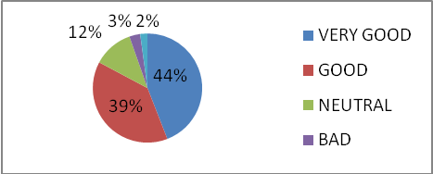
12 | The teachers illustrate the concepts through examples and applications. | 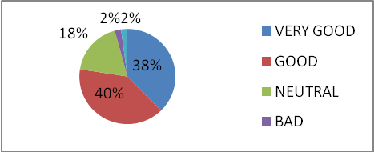
13 | The teachers identify your strengths and encourage you with providing right level of challenges. | 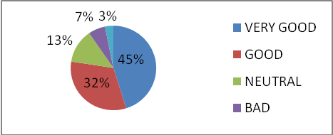
14 | Teachers are able to identify your weaknesses and help you to overcome them. | 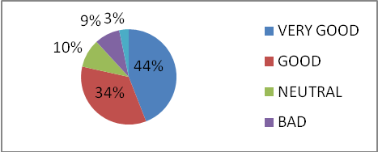
15 | The institution makes effort to engage students in the monitoring, review and continuous quality improvement of the teaching learning process. | 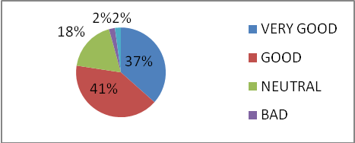
16 | The institute/ teachers use student centric methods, such as experiential learning, participative learning and problem solving methodologies for enhancing learning experiences. | 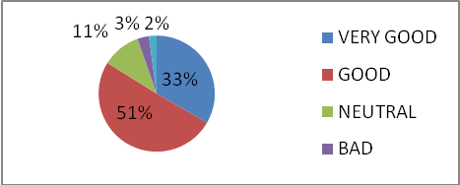
17 | Teachers encourage you to participate in extracurricular activities. | 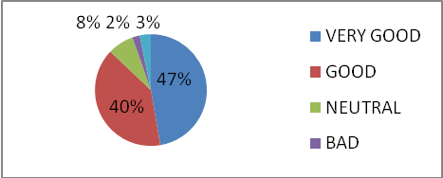
18 | Efforts are made by the institute/ teachers to inculcate soft skills, life skills and employability skills to make you ready for the world of work. | 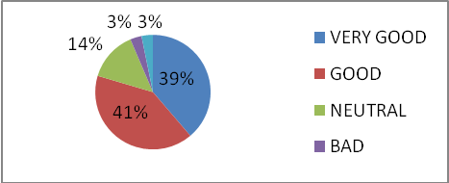
19 | What percentage of teachers use ICT tools such as LCD projector, Multimedia, etc. while teaching. | 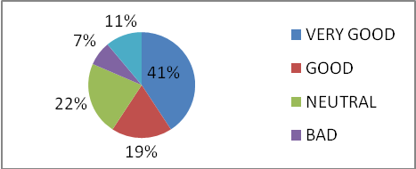
20 | The overall quality of teaching-learning process in your institute is very good. | 